CHAPTER 1
INTRODUCTION

MPages is a web-based platform that enables organizations to create custom workflows within PowerChart. With the ability to pull data in real time on an as-needed basis, organizations can rapidly access relevant data and create custom applications within Cerner Millennium. MPages enables an ad hoc query to Cerner’s clinical decision support system, allowing for proactive and interactive monitoring of real-time patient scenarios crossing many different roles, venues and conditions. [3]

1.1 General Introduction to the Topic
The organization has heavy focus on creating solutions for the products in the healthcare industries. This project aims at improving the efficiency of their web based tool called PowerChart. This project will aim to create custom workflows using patient data such as their health status and display the corresponding details in the PowerChart. Since the tool is a web based tool it includes working on technologies such as CSS, JavaScript, HTML and CCL. CCL is a back-end query language used by Cerner Corporation abbreviated for Cerner command language.

Client Benefits:
- Enables customization of information within PowerChart
- Provides the ability to pull relevant data in real time on an as-needed basis
- Enables user to view, input and interact with data in new ways
- Allows creation of custom applications within the Cerner Millennium structure
- Increases adherence to clinical standards, for example, increasing reimbursement for correct drug usage or decreasing length of stay by improving clinical team response time.

1.2 Major Features
The following data formats are available for MPages tabs: ASCII, RTF, PDF, PostScript and HTML format, which enable the user to interact with the MPage. The powerful toolkit that can be used on any piece of data within Cerner Millennium—and, in some cases, third-party data—to create a wide range of formatted data for end users, for example:
- Consolidate data to present to clinicians in PowerChart to identify at-risk patients for various populations
- Configure Cerner Millennium data in a drillable format for many different role, venues, and conditions.
Having the ability to customize workflows and patient views using custom MPages has been a tremendous help in improving patient safety and provider adoption of CERNER integrated systems. This process will improve as well once the 4.1 standard is released which will allow custom components to be built into existing summary pages. [3]
The project aims at pulling patient data in real time from Cerner products such as Cerner Millennium and displaying them in a better way so as to monitor and analyse patient health status to provide better health care facilities. This helps physicians to better monitor patient health status and recommend health care appropriately.
Focus of this project will be to ensure that the MPages Framework and Architecture is understood in its entirety and concerned person will be able to develop new components from scratch going forward.

1.3 Problem Statement and Objective

Problem Statement
To create a patient search application that pulls patient data in real time from Cerner products such as Cerner Millennium, to monitor and analyse patient health status and incorporate multiplatform compatibility.

Objectives
- Create a Patient Search Web Application.
- To display the patient details based on the search criteria.
Patient details to be displayed are name, age, gender, MRN, patient ID and the patient’s encounter (with the physicians) details such as encounter ID, encounter status, attending provider and encounter type.
- Create a web application which runs on discern.war
- The application has to be a responsive designed application.
- Use any CSS frameworks (Example Bootstrap) to achieve responsiveness.
- Create a CCL program which returns all patients based on the search criteria.
- Use XmlCCLRequest to call ccl scripts.
- Use JavaScript to dynamically build the markup code which renders the report.

1.4 Organization
For over 26 years, Cerner has been a leading healthcare information technology supplier, developing ground breaking solutions to help clinicians organize and access medical data. Cerner has not only improved the overall operational efficiency of healthcare, but ensured a safer environment for patients around the world. More Americans die each year as a result of medical error than from motor vehicle accidents, breast cancer, and AIDS. Cerner has endeavoured to reduce these tragedies by automating and connecting fragmented medical solutions. When the company’s founders—Neal Patterson, Cliff Illig, and Paul Gorup—first came together in 1979 to launch Cerner, information technology (IT) was still a new concept within the healthcare industry. Most facilities still relied on paper medical charts and handwritten files to keep track of patient records. Through its solutions, Cerner has developed a more cohesive infrastructure, in which caregivers have straightforward and effective access to computerized clinical systems, patient records, and billing processes. Cerner solutions extend across the full spectrum of medicine, from radiology to pharmaceutical care. By investing in long-term growth, Cerner has managed to remain on the cusp of the exploding healthcare IT industry. Cerner continues to broaden its market presence and further specialize its solutions portfolio. Working in conjunction with the best hospitals and clinics in the United States and abroad, the company also provides assistance to international and state wide initiatives in its effort to integrate medical data. Cerner has grown to generate more than $1 billion a year, and a significant aspect of this success lies in the loyalty of its nearly 7,000 associates. Cerner: From Vision to Value is a tribute to the diligence of these associates in their quest to deliver superior medical care to patients, while controlling the costs of healthcare services as they confidently look towards the future. [9]

1.5 Area of Computer Science
Web based application development for PowerChart using JavaScript and CCL.

Hardware Requirements:
- Any desktop computer/laptop with Windows 7 or above(32-bit and 64-bit)

Software Requirements:
- Apache Tomcat Server is used to host MPages on user’s browsers to check functionality of the components.
- Knowledge of CCL scripting to extract the records from the Cerner Millennium database.
- Bootstrap framework package to be imported.
- Javascript and CSS scripting for enhancement of the MPage layout and functionalities.

1.6 Report Organisation
The report includes six chapters namely Introduction, Background Theory, Design and Methodology, Implementation and Testing, Result Analysis and Conclusion and Future scope of work. Chapter 1 (Introduction) includes general introduction to the topic, client benefits, major features of the application, about the organisation, the problem statement and objectives, and areas of computer science covered. Chapter 2 includes (Background theory) includes about MPages, about JIRA and Crucible – the tools used for implementing the Agile methodology, literature review. Chapter 3 (Design and Methodology) includes UML diagrams highlighting the activities and functionalities in regard with the user interaction. Chapter 4 (Implementation and Testing) includes implementation of the application and the kind of unit test cases created for validation. Chapter 5 (Result analysis) includes all the white box evidences of the application showing all the functionalities. Chapter 6 includes the work conclusion and future scope of work followed by the references and project details at the end.

CHAPTER 2
BACKGROUND THEORY

The project aims to create custom workflows using patient data such as their health status and display the corresponding details in the PowerChart. Since the tool is a web based tool it includes working on technologies such as CSS, JavaScript, HTML and CCL. CCL is a back-end query language used by Cerner Corporation abbreviated for Cerner Command Language. [5] CSS, JQuery, JavaScript support is required to run MPages on all available browsers. JavaScript and JQuery provide APIs for creating and modifying the MPage components. CCL is used to query Cerner’s clinical databases to fetch patient data which is then displayed on the MPage components.
JIRA is a proprietary issue tracking product, developed by Atlassian. It provides bug tracking, issue tracking, and project management functions. [7]
Git working directory is a full-fledged repository with complete history and full version-tracking capabilities, independent of network access or a central server.
GitHub is a web-based Git repository hosting service, which offers all of the distributed revision control and source code management (SCM) functionality of Git as well as adding its own features. Unlike Git, which is strictly a command-line tool, GitHub provides a web-based graphical interface and desktop as well as mobile integration. It also provides access control and several collaboration features such as wikis, task management, and bug tracking and feature requests for every project. [1]

2.1 About MPages
There are two primary MPage views at the chart level: Summary and Workflow.
A view is composed of a collection of components. It provides the clinician with a high-level view of information contained in the chart. Its aim is to help them quickly understand the status of the person or persons in their care while allowing them to complete a majority of self-directed actions from the view. This eliminates the need to navigate to multiple portions of the chart to gain that high-level understanding. When necessary, the view provides easy navigation to and from other areas of PowerChart to aid in the completion of actions which may not be supported in the view.
A View Point presents the clinician with the specific information necessary to complete a defined set of actions as they undertake major activities common for their role and venue. It is composed of one or more chart level views. Summary and Workflow Views can both be included in a single View Point. [3]
A component contains a collection of data. Many components also support the clinician in taking specific actions as appropriate for the information it contains. Each view contains components. Figure 2.1 depicts the components that are specifically designed for use in Summary Views. Data display is often condensed due to the component being optimized for use in one to three column Summary Views.
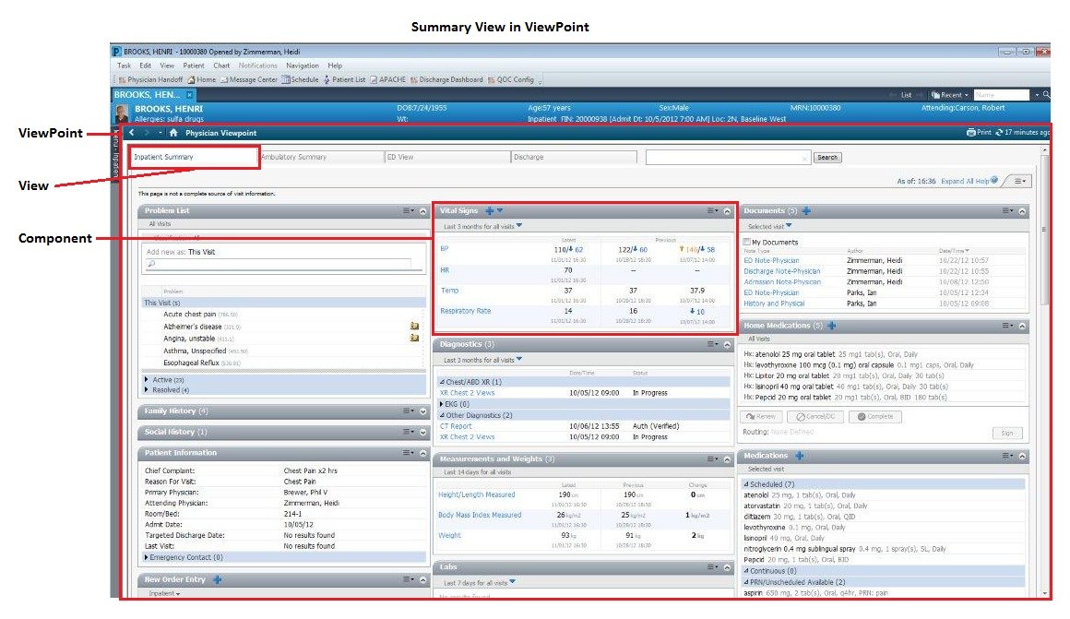Fig. 2.1 Summary view in View Point

Workflow Components are specifically designed for use in Workflow Views. They can contain more data than a typical Summary Component. The clinician may be able to take similar actions from a Workflow Component as they can from a Summary Component, but the capabilities supported by individual components will differ. Workflow views as represented in figure 2.2 display components in sequential order based on workflow and in a single column. It also contains a navigation pane so the clinician can navigate directly to a specific component in the view with a single click and maintain context for where they are within their work flow.

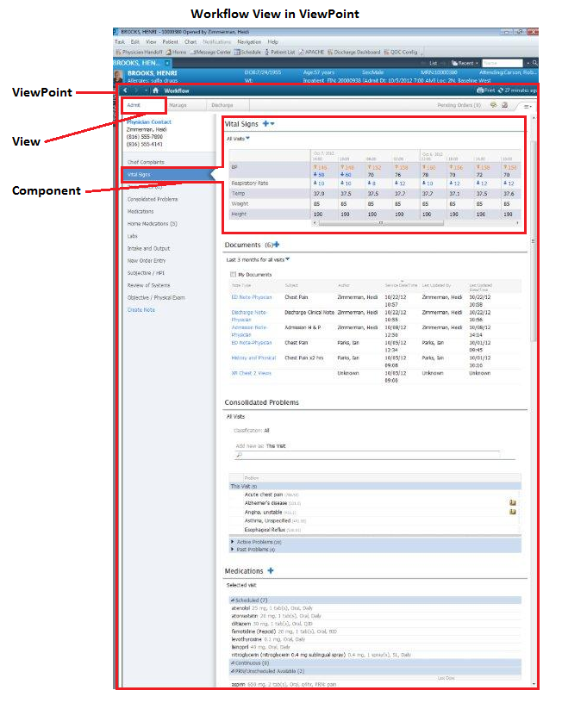Fig. 2.2 Workflow view in View Point

JIRA
JIRA is the tracker for teams planning and building great products. Thousands of teams choose JIRA to capture and organize issues, assign work, and follow team activity. At the desk or on the go with the new mobile interface, JIRA helps the team get the job done. Tasks, ideas, and requests are hiding in documents, people's heads, and deep in our inbox.
JIRA is used to capture and organize our team's issues, prioritize and take action on what's important, and stay up to date with what's going on around. JIRA makes all of this easy, so that the team spends less time managing the work and more time building great software. [7]

Crucible
Code review is inherently iterative. It helps to review and comment on the code and tracks which files are already covered, then resets them as new revisions are added. [8]
Crucible bridges the gap for distributed teams and makes code review possible.
- Instant feedback on review activity via email and RSS
- Audit trail of all review activity
- Activity streams including source code and code reviews

2.2 Literature Review
The Mobile Clinical Summary MPages [3] view gives physicians and other authorized users anywhere, on any device, access to important clinical information. It extends select functions of the Inpatient Summary MPages view to web-enabled mobile devices like the iPhone, iPad, Blackberry, Android and others, in real time.
Users familiar with the Inpatient Summary will find the Mobile Clinical Summary to be similar with only small variances in operation and layout due to a particular device's user interface.
With the Mobile Clinical Summary MPages view, physicians and other authorized users can do the following things:
- View their Patient Lists as defined in PowerChart
- Perform a patient search
- View their schedule
- Establish a Patient-Provider relationship
- Review inpatient clinical information
- Demographics
- Patient information
- Vital signs and trending
- Problems

CHAPTER 3
DESIGN AND METHODOLOGY

3.1 Design:
UML (USE CASE) diagram was designed to highlight the interactions of the User with the application:
In this scenario, the Actor is the physician, clinician etc.
The below figure 3.1 depicts that the end client, on using the search engine can enter the search criteria (such as name, MRN, FIN, birth date), view the patient details as well as the patient specific encounter details and clear the search fields. The user can also access the application from any platform.

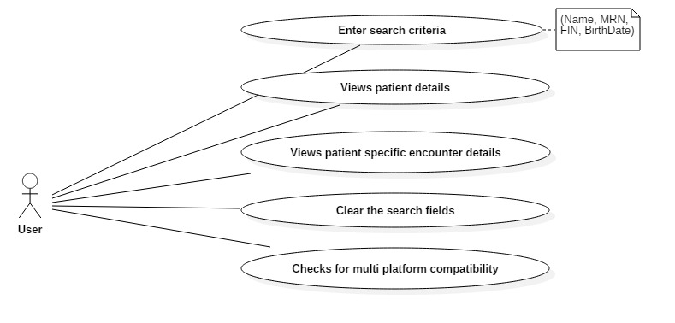Fig. 3.1 Use Case Diagram showing end client interactions

While the project was run, the various activities involved during the user’s interaction with the application is depicted in figure 3.2. The loadJSON() function was invoked after the search criteria was entered. The search values were put into a local data structure and the information was accordingly extracted using the search filters (the name tags associated with every search criteria field). On extraction, the data was stringified and returned as a JSON object.
On returning to the main page, the script request object was created and values were assigned to it. Scriptrequest.js helps create XmlCCLRequest to contact and extract data from the Cerner Millennium database by specifying the driver program, parameters (applicationID, taskID, requestID), converting it into a DataBlob, Asynchronous indicator for set to true so that other actions can be performed simultaneously before the data is retrieved and thus invokes a successcallback if the extraction was successful. The status of the reply object is checked for success or failure. If it’s a success, data is sent to the renderData function to stringify, parse, iterate through the length and hence, display the details of the patient.

UML ACTIVITY diagram was designed to show the actions performed while the project was run.
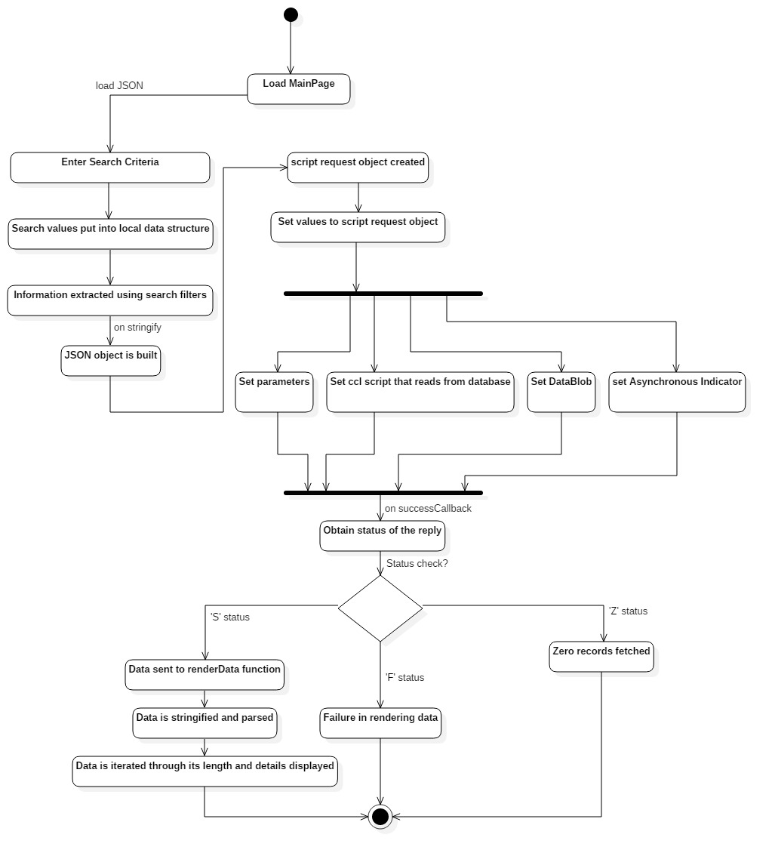
Fig. 3.2 Activity Diagram to depict the functionalities of the application

3.2 Methodology:
The project uses the Agile methodology of Software Development Life Cycle as shown in figure 3.3. Agile approaches are typically used in software development to help businesses respond to unpredictability.
The Agile framework used for the project is Scrum. Scrum is an iterative and incremental agile software development framework for managing product development. A key principle of Scrum is its recognition that during a project the customers can change their minds about what they want and need.
The software development team consists of a Product Owner, Strategist, Solution Architect, Developers, Test Analysts and a Scrum Master. The Scrum Master ensures that the Scrum process is used as intended.
The project is developed in the form of iterations. Each iteration plans to implement new User Stories (or Function Requirements). Every User Story is divided into tasks such as Requirements, Investigation, Design and Code, Code Review, Design Review, White Box Testing and Black Box Testing or Integration Testing.
A prototype of the project is shown to the Scrum Master at the end of each iteration. Daily Scrum meetings are planned to discuss the tasks to be completed.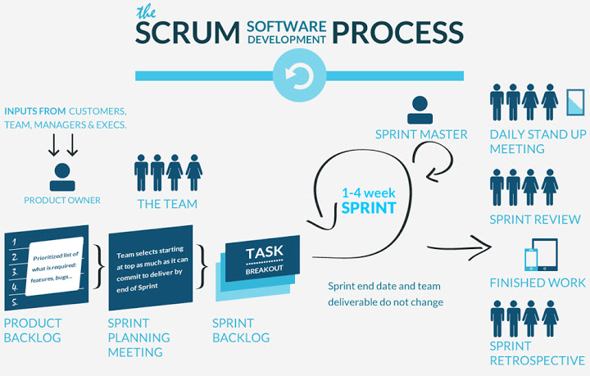
Fig. 3.3 Methodology: AGILE
CHAPTER 4
IMPLEMENTATION AND TESTING

4.1 Implementation:

Deploying discern explorer on browser
- The discern.war file is deployed on the Apache Tomcat server which contains the data to host MPage components in a browser and can be accessed using a specific URL:
http://localhost:8080/discern/Project/patientsearch.html where the project folder contained the project related files.
- This file also contains static content files for regular components as well.

Modifying Bedrock settings
- Create a view in bedrock settings and add custom workflow component to it.
- Create a viewpoint in bedrock settings and link the view created above to this viewpoint.
- Modify MPage settings in bedrock to include the above created viewpoint.

Creating a tab in Prefmaint
- Create a tab in prefmaint to add static content path and input parameters. This tab will be visible in PowerChart and will be used to host MPage components.
- Mention the driver program which the MPage will use to fetch the data.

Creating the Javascript and CSS files
- The .js file for component is created using Brackets.
Patientsearch.html file includes the following .js files
patientsearch.js – The main .js file that contains the main page page elements, the search fileds, the buttons and the anchor to all requests and replies.
JSONconvert.js – This file converts the search criteria text from the .js file and stringifies it into JSON format for the patient details (Name, Age, Gender, MRN, Patient ID)
scriptrequest.js – This file helps create a scriptrequest object to contact and extract data from the Cerner Millenium database by specifying the driver program, parameters (applicationID, taskID, requestID), converting it into a DataBlob, Asynchronous indicator for asynchronous data thus invoking a successcallback if the extraction was successful.
EncountersJSON.js - This file converts the search criteria text from the .js file and stringifies it into JSON format for the patient encounter details (Encounter ID, Encounter Status, Attending Physician, Encounter Type)
https://ajax.googleapis.com/ajax/libs/jquery/1.12.0/jquery.min.js and http://maxcdn.bootstrapcdn.com/bootstrap/3.3.6/js/bootstrap.min.js - contain all bootstrap plugins, whose functionalities were used to generate responsiveness to the MPage.
- The .css file for component is created using Brackets: http://maxcdn.bootstrapcdn.com/bootstrap/3.3.6/css/bootstrap.min.css - The css file used for implementing the dynamic and responsiveness of the MPage.
style.css – The defined .css file describing the presentation of the MPage written in markup language.

Fetching data from Cerner database
- Patient information is fetched from Cerner’s database and returned in the form of a JSON object
- This JSON object is parsed to obtain information and display on the custom component
- Retrieves information for patient as per the search criteria and display on the custom component created to show a patient’s information.
The figure 4.1 shows a view of an MPage.
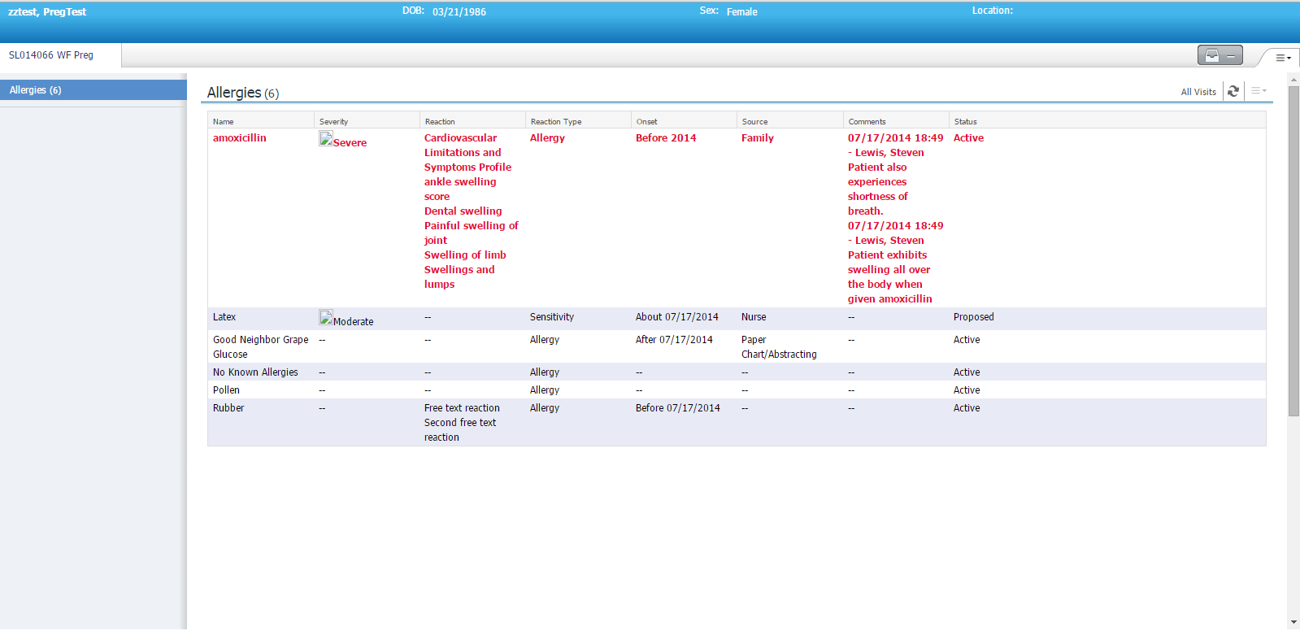
Fig 4.1 a typical MPage view with components

The required components are added to the view in View settings in bedrock which define placeholders for components. The Viewpoint setup is required to link multiple views to a viewpoint. These views will appear as tabs in an MPage.
PowerChart is used to host MPages. Each MPage appears as a tab on the left pane. Multiple views can host inside an MPage.

Front End
- The front end is created using JavaScript
- The styling is done through CSS

Action
- The user can enter searching criteria to view the patient information hosted on an MPage.

Unit Modules for back End
- The data from Cerner Millennium’s database is fetched using Cerner command language (CCL).
- This data, obtained as a JSON object, is then parsed to display information on a component.
- Maven build of the all custom components which creates a .jar file to deploy on the server.
- Creating and modifying CCL scripts to fetch data from Cerner’s database.
- Integrating these components into the MPage view.
- Black box testing of the MPage.
- Documentation of the entire component.

4.2 Testing:
- Create test cases for all functions in the .js file
Jasmine unit testing suite is used to test JavaScript for any errors and warnings. It is a behavior driven development framework for testing Javascript code and has a clean, obvious syntax so that you can easily write tests. [6] This test also allows to check semantic and syntactic errors in the script file. For all the search fields, it helps to validate the type of data that is entered to prevent the Z or F status from the script request reply.

CHAPTER 5
RESULT ANALYSIS

On the code implementation, the following results were obtained and inferred:
The Apache Tomcat service was started and the index webpage patientsearch.html was loaded on the server.
The bootstrap framework was extended and used to implement the dynamic nature of the webpage elements. On maximizing the web application window as shown in figure 5.1 the view of the MPage included the search criteria fields and the search result space:

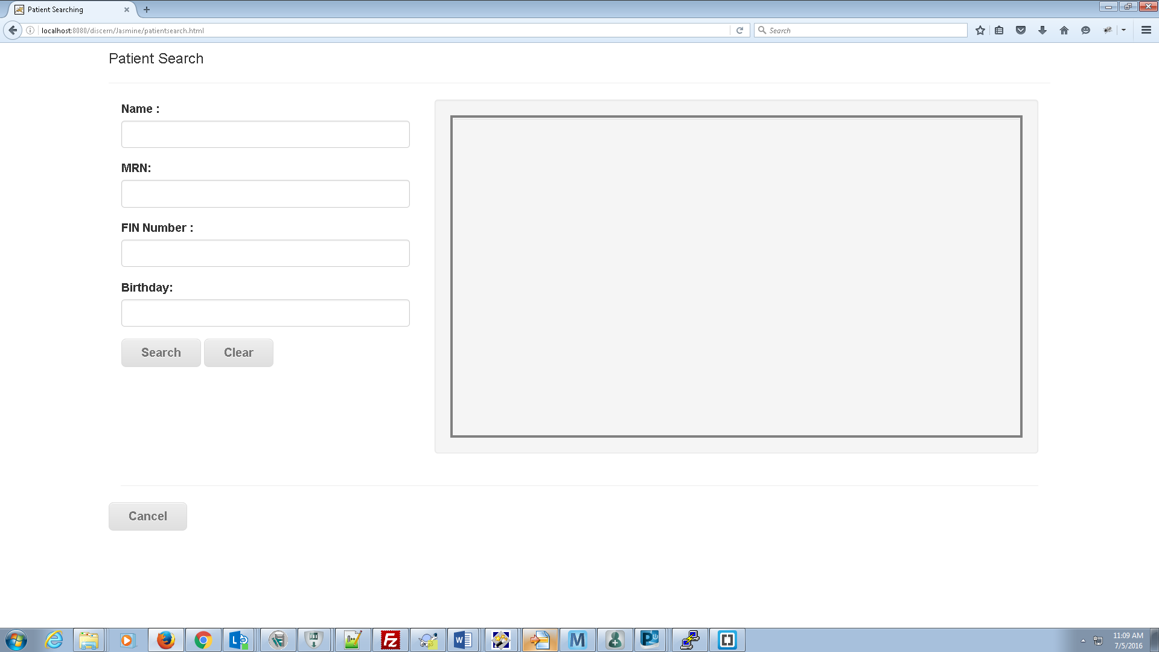
Fig 5.1 Maximised view of MPage

Figure 5.2 shows how on minimising the window, the webpage was found to be responsive. The search fields and the control buttons were compressed but still fit within the window boundary:
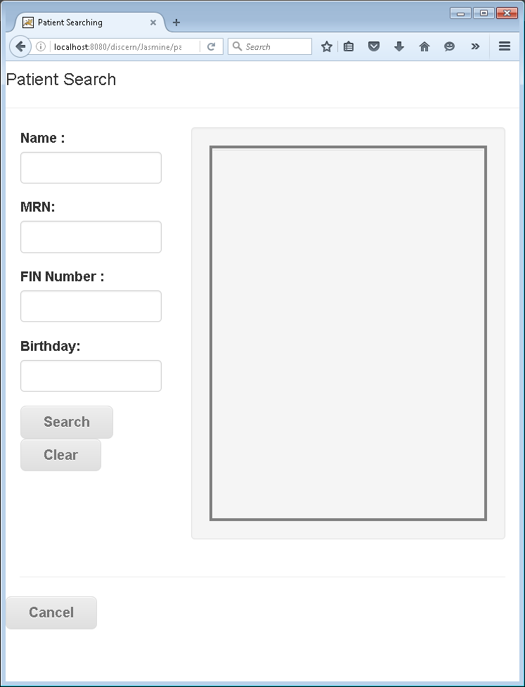
Fig 5.2 Compressed view of MPage

The text field – Name – allowed only text to be entered and no numerals. The number fields like FIN and MRN fields allowed numerals. The search criteria, name (Alan) was typed as an example in figure 5.3:

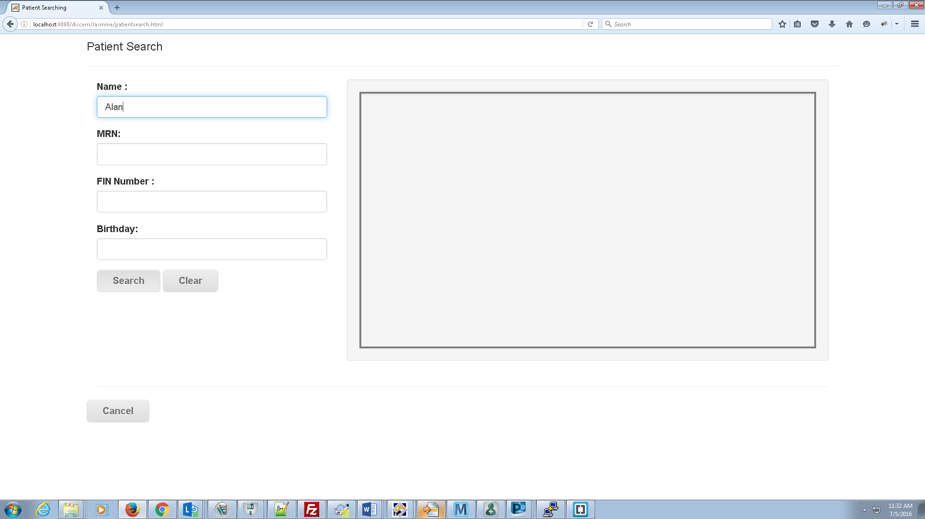
Fig 5.3 Search criteria Name entered

The search criteria was converted to JSON, the script hit the Cerner Millennium database and the reply to the request obtained, (in JSON) and was parsed and displayed:
The figure 5.4 shows when the scriptrequest reply object was of status S (Success)

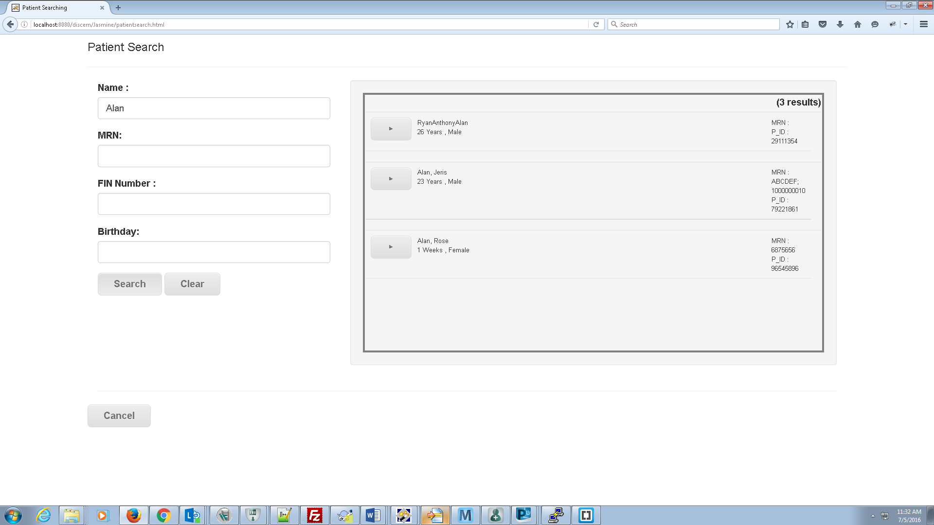
Fig 5.4 Patient details retrieved

On hitting the drop button, the patient’s encounter with the physician details were extracted by the same script but with a different request ID and subsequently the respective encounter details were displayed:

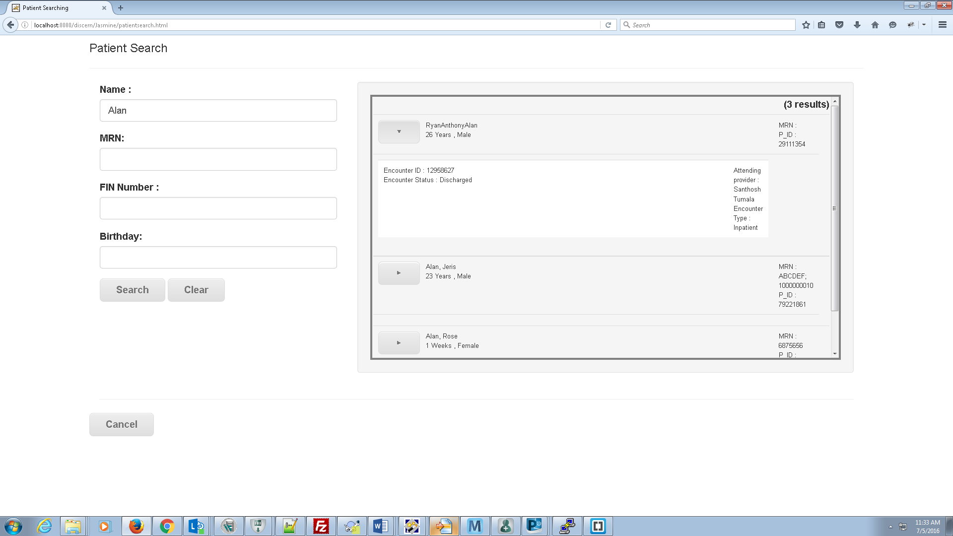
Fig 5.5 Encounter details of the patient

The below figure 5.6 shows the search results obtained on searching with another criteria – MRN.
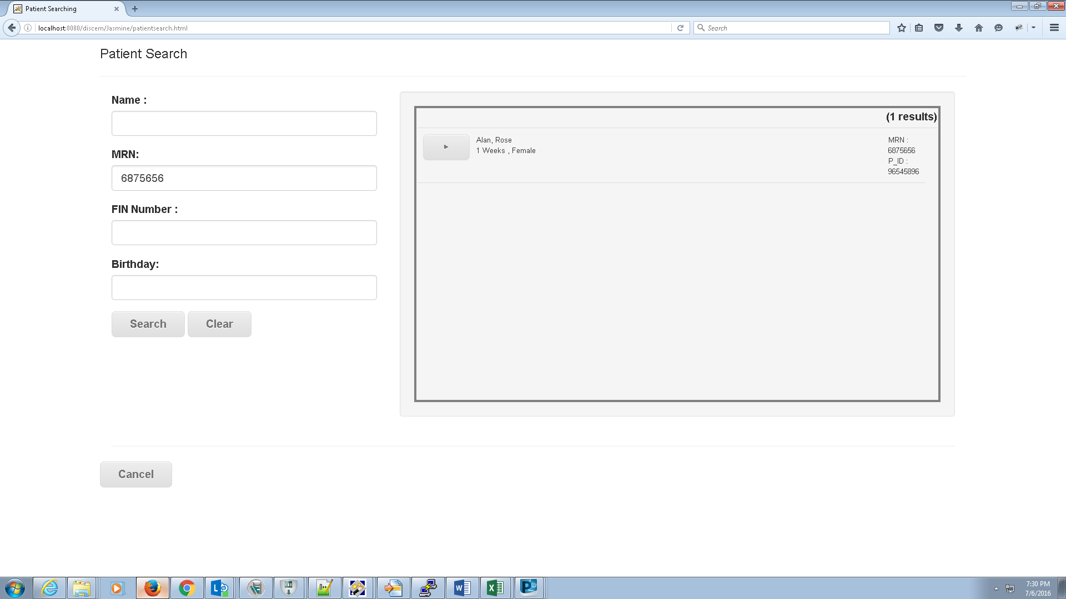
Fig 5.6 Search criteria MRN entered

If the scriptrequest reply object was of status Z then it meant zero records were fetched from the database.
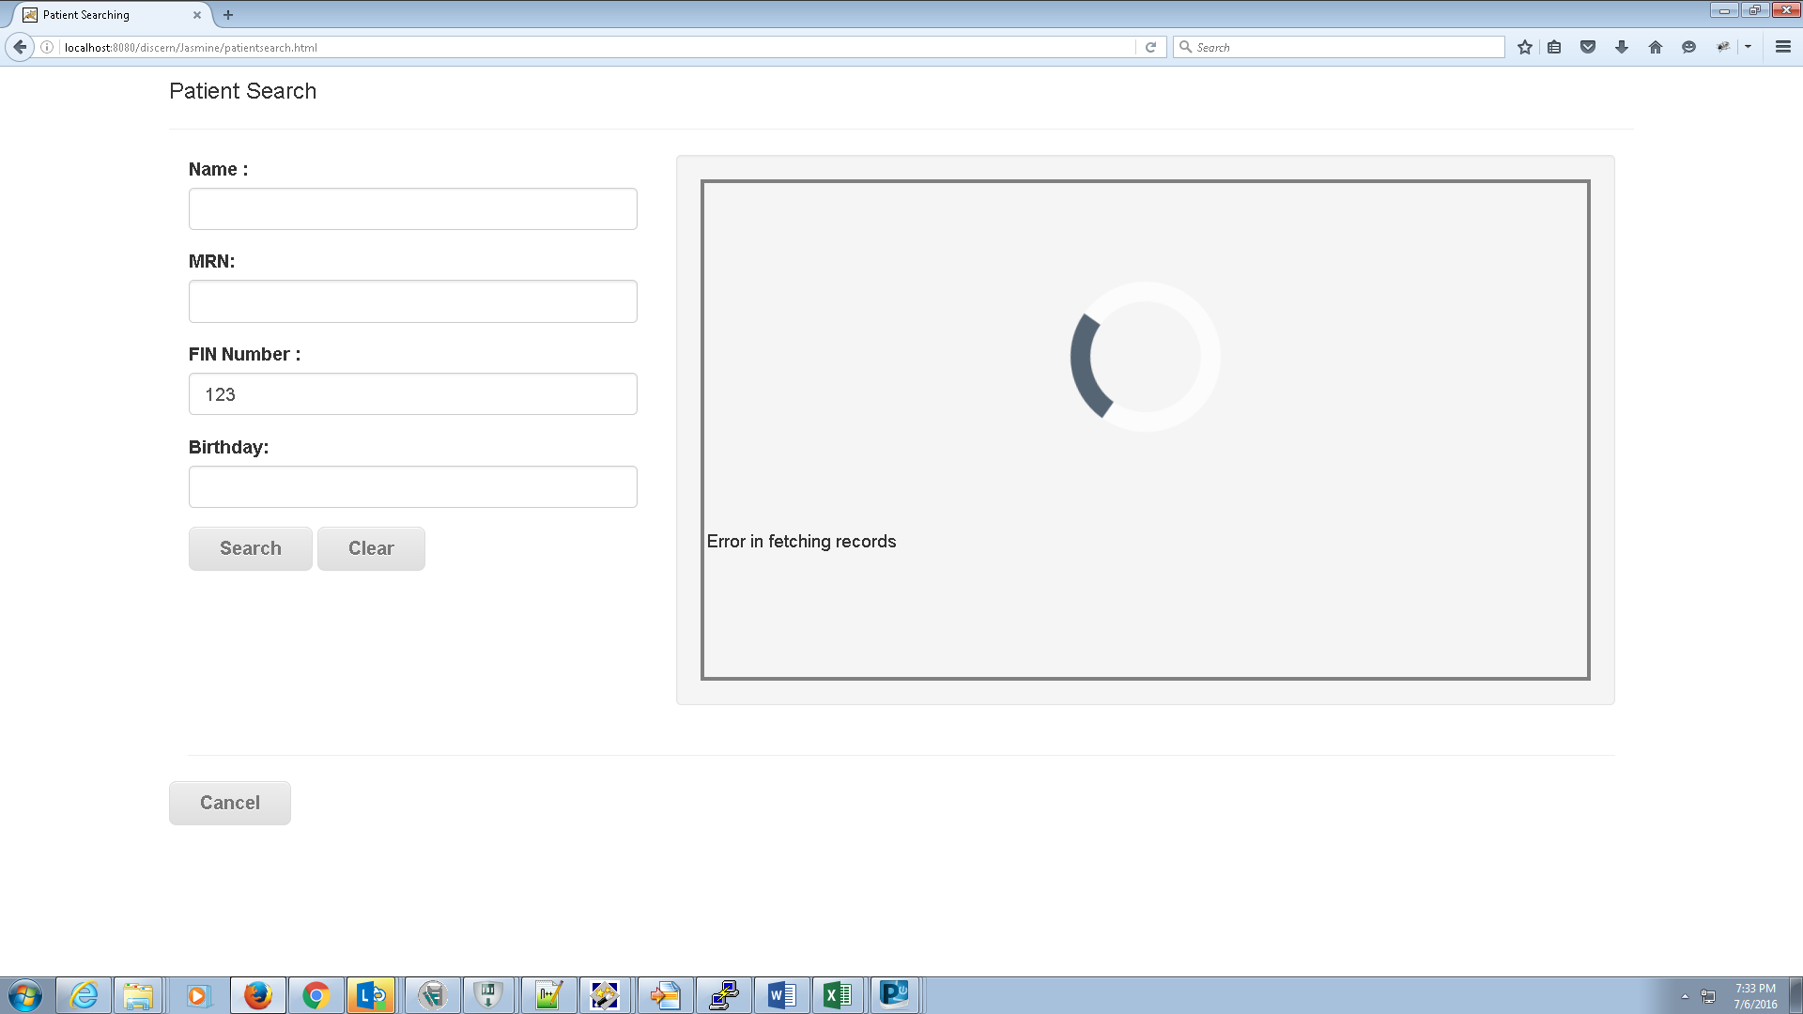
Fig 5.7 Error message – 0 records fetched

If the scriptrequest reply object was of status F there was an error while fetching records from database.

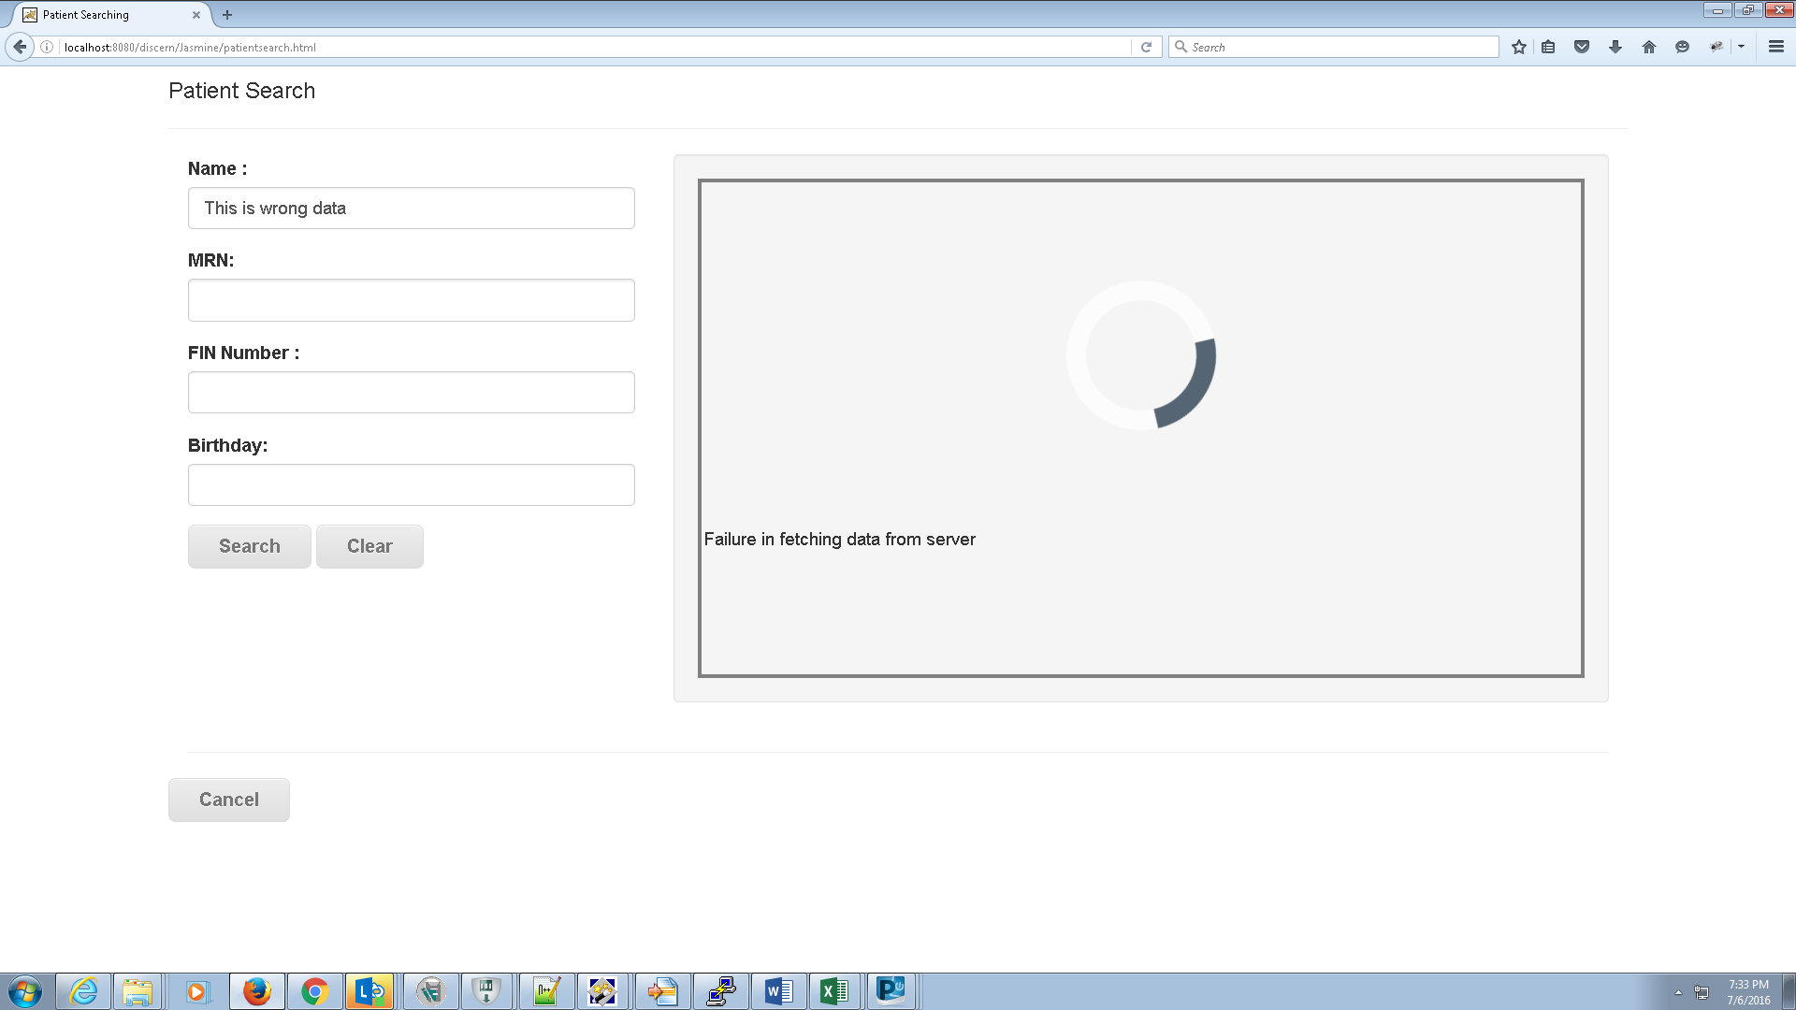

Fig 5.8 Error message – failure in reaching database

CHAPTER 6
CONCLUSION AND FUTURE SCOPE OF WORK

6.1 Work Conclusion
In conclusion to this search engine, thus created, the MPage was found to be responsive and the search criteria fields were dynamic. On hitting the search, the required details were extracted from the database which showed the script ran successfully for the right data entered. The respective encounter details were also displayed. This helps physicians to better monitor patient health status and recommend health care appropriately.
The physicians on using this search engine will have the advantage of a more defined and well-constructed search engine to render the desired results. The various descriptions of each search result will be displayed either in a summary or a workflow view. The framework also concerns the compatibility on different devices. The type of data entered in the search fields were validated. Thus, it helps physicians to better monitor patient health status and recommend health care appropriately.

6.2 Future Scope
The future scope of this project work can be extended to more tools such as tools for adding orders, procedures, diagnosis, medications or tools for monitoring the health status of patients or analysing the quality of the physicians, clinicians etc. to be more responsive and dynamic. By altering the kind of data retrieved from the database, we can view more data as per convenience and requirement. The search criteria can be extended to more fields such as the hospital name or the recent encounter date.
REFERENCES

- https://github.training.cerner.com/DevCenter/Web-based-Patient-Search (February, 2016)
- https://wiki.ucern.com/display/public/reference/Bedrock+Overview (February , 2016)
- https://wiki.ucern.com/display/public/reference/All+About+MPages+Architecture (March, 2016)
- http://www.w3schools.com/bootstrap/default.asp (April, 2016)
- https://wiki.ucern.com/display/1101discernHP/Discern+Explorer+Help (May, 2016)
- http://jasmine.github.io (May, 2016)
- https://jira2.cerner.com/browse/ (April, 2016)
- http://crucible05.cerner.com/ (June, 2016)
- http://cerner.com (January, 2016)
PROJECT DETAILS

Student Details
Student Name | FREYA GENESIS D’MELLO
Register Number | 120911529 | Section / Roll No | A / 43
Email Address | Genesis.94@gmail.com | Phone No (M) | 8971005759
Student Name
Register Number |  | Section / Roll No
Email Address |  | Phone No (M)
Project Details
Project Title | Patient Search
Project Duration | 4 months | Date of reporting | 09-07-2016
Organization Details
Organization Name | Cerner Corporation
Full postal address with pin code | H2, Manyata Embassy TechPark, Nagavara, Bangalore - 560045
Website address | Cerner.com
Supervisor Details
Supervisor Name | Mr. PPBN, Moorthy
Designation | Software Architect
Full contact address with pin code | H2, Manyata Embassy TechPark, Nagavara, Bangalore - 560045
Email address | Moorthy.PPBN@Cerner.com | Phone No (M) | 9986506970
Internal Guide Details
Faculty Name | Poornalatha G, Ph.D
Full contact address with pin code | Dept. of Information & Communication Technology, Manipal Institute of Technology, Manipal – 576 104 (Karnataka State), INDIA
Email address | Poornalatha.g@manipal.edu

